**Computer Engineering -CSC 7011**

**Prof. Stephen Taylor**

**Arnika Vishwakarma (@01367603)**

**FINAL EXAM**

**Question :** Consider the AND COMPLEMENT IMMEDIATE instruction,

andci rt,rs,*Immediate*

|  |  |  |  |
| --- | --- | --- | --- |
| (31:26) 010100 | (25:21) RS | (20:16) RT | (15:0) immediate operand |

This instruction uses the otherwise unused ALU control bits 100, which outputs A & (!B) (using C notation for the logical operators.)

It takes the A operand from register RS and the B operand from the (sign-extended) lower 16 bits of the instruction, and stores the result in register RT.

Work out the values of all the control signals shown on the datapath diagram which would be needed to implement the AND COMPLEMENT IMMEDIATE instruction.

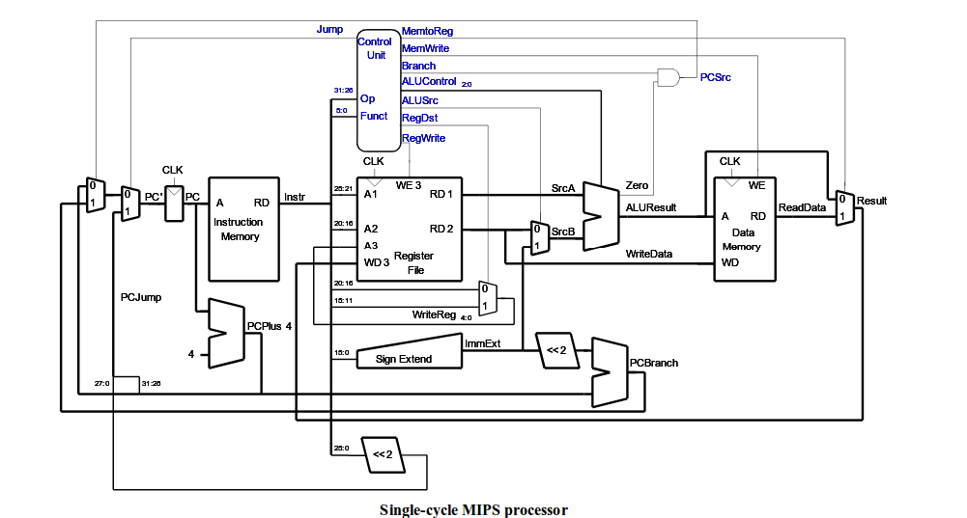

**Solution:**

**Truth table of A & !B**

|  |  |  |  |
| --- | --- | --- | --- |
| **A** | **B** | **! B** | **A & !B** |
| **0** | **0** | **1** | **0** |
| **0** | **1** | **0** | **0** |
| **1** | **0** | **1** | **1** |
| **1** | **1** | **0** | **0** |

Following are the values of all the control signals shown on the datapath diagram:

**RegWrite = 1** (To write the result to the register file RegWrite is 1 on the rising edge of the clock)

**RegDst = 0** (The destination register is specified in the RT field of instruction instr 20:16)

**ALUControl = 100** (As the given instruction is AND complement immediate)

**ALUSrc = 1** (SRC B comes from the immediate sign extended Immediate)

**MemtoWrite = 0** (The instruction doesn’t write data to data memory that’s why the value of MemToWrite is 0)

**Jump = 0**

**Branch = 0** (The given instruction is not a branch that’s why the value of branch is zero)

**MemToReg = 0** (The result comes from the ALU, not from memory, that’s why MemToReg = o)